School Supply List
2023-2024
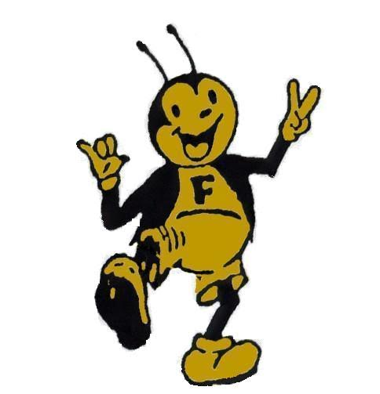

The City of Fowler has generously offered to supply our PK-6th grade students with school supplies for the 2023-2024 school year. Thank you City of Fowler!

Parents, if you would like to help provide for some of the items the city will not be able to cover, our teachers will gladly accept donations of Kleenex, Clorox wipes, and Expo markers. You can send them to school with your children. Thanks in advance!

